Classroom commands
- Good morning/ 8. 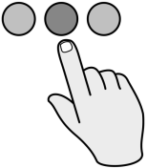 Point
Hello.
- 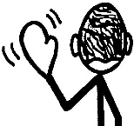 Goodbye. 9. 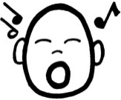 Sing
- 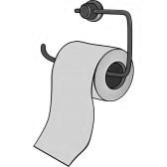Can I go to the 10. 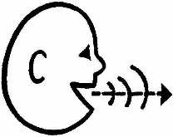 Say
bathroom, please?
- 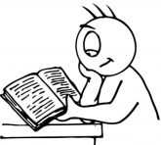 Read. 11. 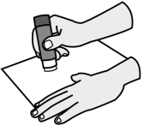 Stick
- 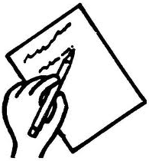 Write. 12. 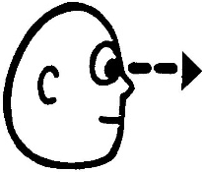 Look
- 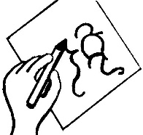 Draw 13. 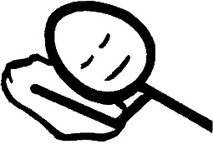Sleep
- 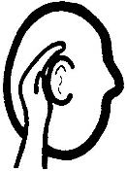 Listen 14. 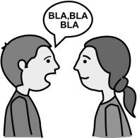 Work in
pairs.
Classroom commands
- Good morning/ 8. Point
Hello.
- Goodbye. 9. Sing
- Can I go to the 10. Say
bathroom, please?
- Read. 11. Stick
- Write. 12. Look
- Draw 13. Sleep
- Listen 14. Work in
pairs.

