Old Macdonald had a farm, E-I-E-I-O. And on his farm he had a …, E-I-E-I-O.
With a "…" here and a "…" there, here a "…" there a "…",Everywhere a "…" Old Macdonald had a farm E-I-E-I-O.
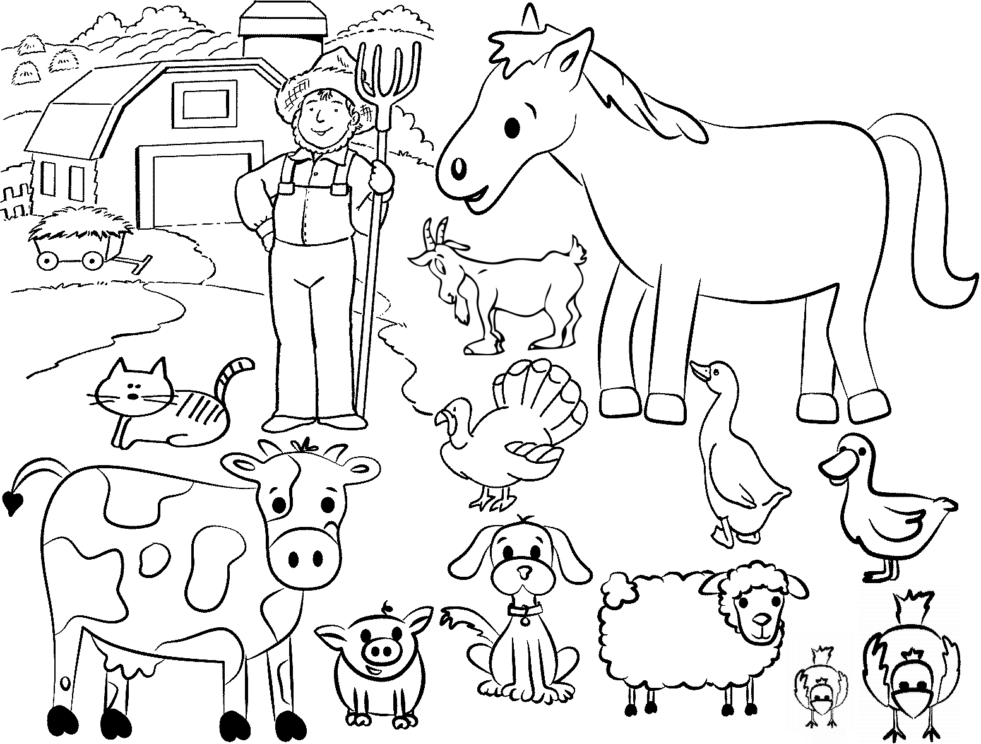
Old Macdonald had a farm, E-I-E-I-O. And on his farm he had a …, E-I-E-I-O.
With a "…" here and a "…" there, here a "…" there a "…",Everywhere a "…" Old Macdonald had a farm E-I-E-I-O.

