L e t m e i n t r o d u c e m y s e l f

*Personal information*

**What is your name ?** My name is ____________________________________

**How old are you ?** I am _____ years old.

**Where do you live ?** I live in ________________________________________

**Where were you born ?** I was born in___________________________________

**What is your phone number ?** My phone number is _________________________

Picture yourself

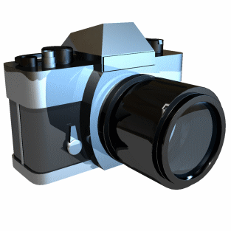

My interests

My favorite food is ______________________

My favorite book is ______________________

My favorite TV program is _________________











What do I like ?

I love _________________

I like __________________

I hate _________________

What do I look like ?

I have ________________

I have ________________

I am _________________

I am _________________