Pancake Day
(a lesson for teenagers of pre-intermediate/intermediate level)
- Warmer

Picture of pancakes on the screen.
Work in pairs. Discuss the following questions.

- When is Pancake Day in your country? In Great Britain?
- Do you celebrate Pancake Day?
- Do you have any family traditions? What are they?
- FB: Tell about your partner.

- TASK 1
- Picture of Jake the Dog (cartoon for teens “Adventure Time”) making pancakes.
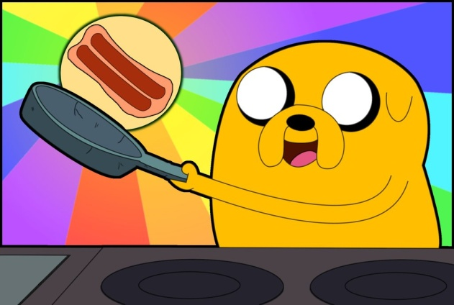

- Lead-in. Discuss the questions in pairs.
- Who is it? What is he doing?
- What do you usually eat your pancakes with?
- Can you make pancakes? What ingredients do you need?

FB: Tell about your partner.

- Presentation of the target structure (Imperatives)
PTV (with pictures): nourishment, to pour, to grab, grease, wire whisk

1) Work in pairs.Put the lyrics in the correct order. Listen to the song and check.
(the teacher cuts out the lyrics before the lesson)
(I) wake up in the morning and there's one thing on my mind
My tummy starts to rumble,(I) couldn't help it if I tried
There's so much stuff to do today, so we should start it right
I need to get some nourishment, or else I'll start to cry!

I walk into the kitchen and I don't know what to eat
I'm trying to decide between a cake and strips of meat
But they both sound so good, to make just one would be a crime!
So mix them together and we'll have ADVENTURE TIME!

Chorus:
Bacon pancakes, makin' bacon pancakes
Take some bacon and put it in a pancake
Bacon pancakes, that's what it's gonna make
Bacon pancaaaaakes!

Turning on the stove and then it's time to grab a pan
We need to get it nice and hot and make that bacon great!
Be careful and don’t let the grease go crazy when it heats
Or else it may just skip and hop and burn your hands and feet!

Now that we have our bacon, grab that Pancake Powder Mix
We'll need a cup of water, several eggs, a wire whisk
Put it all together and y mix it in a bowl
Grab yourself another pan and then you're on a roll!

Chorus x2

And now the moment we've been waiting for,
Pour bacon in the pancake bowl!
We cook, and when the pancakes meet their end...
Gather round and do it ALL AGAIN!

- How does Jake the Dog make his pancakes? What is the recipe? Underline all the imperatives in the song.
- Elicit the imperatives
- CCQs:
- Does a verb have an ending?
- Do you use a pronoun “you”?
- Do you use imperatives to give instructions?

3)Drilling(all together, one by one) (pronunciation, intonation, structure Verb+other / Don’t+verb+other).
Mix it in a bowl
Don’t let the grease go crazy.

- Practice
- Controlled practice. (Ss work individually, check in pairs,then all together)
Put the verbs in the instructions in the correct order.
Flip over, roll up, Stir, Add(x3), Mix, Pour, Stir, Beat, Cook,

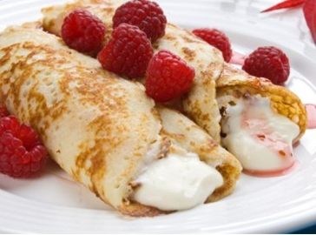

Palačinky (Czech pancakes)

Ingredients

1 cup flour
2 eggs
1 cup milk
1 teaspoon sugar
1 tablespoon butter
1/2 teaspoon salt

Filling

Jam or jelly
Fresh fruit
Nutella

Toppings

Cream
Sugar
Cinnamon
Chopped nuts

- ______flour, sugar, and salt in a bowl.
- ___the eggs, one at a time.
- _____some milk.
- ____ until the batter is smooth.
- _______ in melted butter.
- _____ 1/2 cup batter into a pan.
- _____batter until it is brown. Then ______ and cook the other side.
- Add fillings and ______.
- _______toppings.
- Semi-controlled practice. (in pairs)

Step by step recipe: Pancakes.
  - Put the pictures in the correct order.
  - Use the words in the box to write a recipe.

TASK 2 (production)

- You have invited your friends for dinner. What will you cook? Write your favourite recipe. Use ex.1 as a model.

- Exchange the recipes with your partners. At home, cook your partner’s favourite food and bring it to the lesson.

