**T E S T 2**

**Ime in priimek: Razred: Datum:**

1. **Poglej sličico, preberi ter ustrezno pobarvaj predmete.**

**___/8**

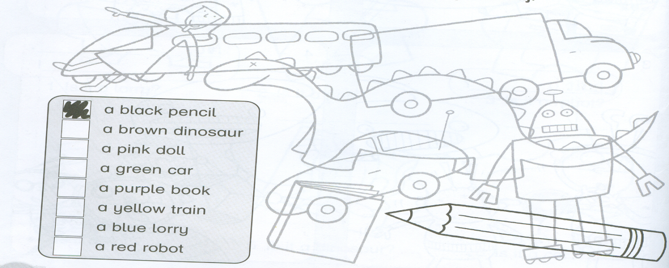

1. **Besede iz okvirčka vpiši pod ustrezno sličico. Dve besedi sta odveč.**

**___/ 9**

DOCTOR'S BAG SKIPPING ROPE PENCIL CASE CAKE

TENT TRAIN CAT ROBOT CAR CROWN BOOK

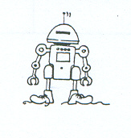 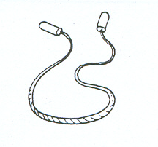 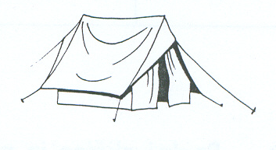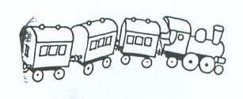

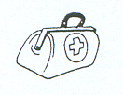 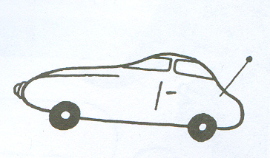 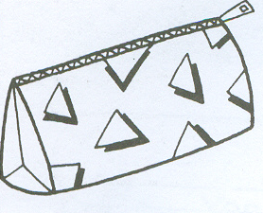 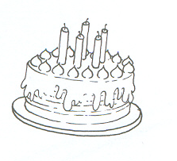 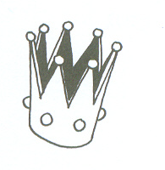

1. **Poglej sličico ter trditve označi kot pravilne ali napačne. ___/7**

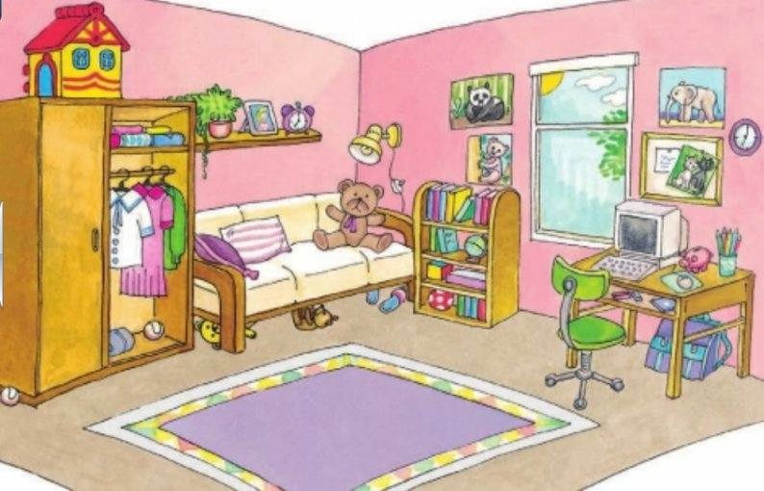

|  |  |  |
| --- | --- | --- |
| TRDITEV | T | F |
| The poster doll's house is in the wardrobe. |  |  |
| The computer is under the bed. |  |  |
| The wardrobe is next to the bed. |  |  |
| The schoolbag is under the desk. |  |  |
| The poster is on the chair. |  |  |
| The teddy bear is on the bed. |  |  |
| The ball is under the bed. |  |  |

1. **Poglej število in ga napiši z ustrezno besedo iz spodnjega okvirčka.**

**___/6**

FIVE SIXTEEN NINETEEN

TWELVE TWENTY THIRTEEN

13 - _______ 5 - ________

16 - _______ 19 - ________

20 - _______ 12 - ______

1. **Oglej si spodnjo sliko in dopolni besedilo z ustrezno besedo.** __/10

NAPIŠI USTREZNO ŠTEVILKO.

____This is a bath. ____ This is a shower. ____This is a mirror.

____This is a bed. ____This is a fridge. ____ This is a table

____This is a picture. ____This is a lamp. ____ This is a toilet. ____ This is a sofa.

61

21

81

43

1019

71

143019

12411019

1351019

91

3

112019

51

1

