|  |
| --- |
| **TEST 2**  Ime in priimek: Razred: Datum:  Točke / ocena: __/57 |

**A. BESEDE DOPOLNI IN JIH ZAPIŠI PO VRSTI. __/7**

DAYS OF THE WEEK ARE:

F _ _ D A Y ___________________

S _ _ U R D A Y ___________________

T _ E S D A _ ___________________

W E _ _ _ S D A Y ___________________

M _ _ D A _ ___________________

T H _ R _ D A Y ___________________

S _ _ D A Y ___________________

**B. NA PRAZNA MESTA VPIŠI USTREZNO BESEDO IZ OKVIRČKA. TRI BESEDE SO ODVEČ. Pazi na pravilen zapis. ___/11**

AT ENGLISH WALK TO SUBJECT IN WAKES HAVE FACE TEETH LISTEN PAST DO IS

My name _________Tim. Iam 11 years old. I am _______________ and I **live** with my parents, my brother and my sister in London, Great Britain. My day starts_______ half past seven, when my mother___________me up. I take a quick shower and put on my school uniform. We all**_____________** breakfast at 8 o’clock. After breakfast, I brush my __________ and combmy hair. I go to school at half ___________ eight. My favourite ______________ is Maths. I come home at two o’clock and **_______** my homework.In the afternoon I go for a ________________. Before I go to sleep, I usually ___________ to music.

**C. OGLEJ SI SLIČICE IN Z BESEDO NAPIŠI, KOLIKO JE URA. ___/5**



It's**______________ ________________ _______________**



**_________________ _________________**

**D. POVEDI DOPOLNI Z USTREZNO BESEDO. ___/8**

There are four seasons in Slovenia. My favourite season is __________ because I can _______ in the sea and play in the sand. Summer is hot and __________.

I don't like winter because it's very cold and ___________.

The weather in spring is __________ and nice and we can __________ a picnic and play outside.

In September, _________ and November there is autumn. It is sometimes windy and __________ and days are short.

 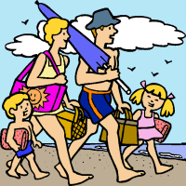 

**E. OGLEJ SI SLIČICE IN DOPOLNI POVEDI. Napiši, kaj kdo igra, zbira ali dela v prostem času. ___/9**

Tina_________________________________________________________________________________________________________________________________________________________________________________

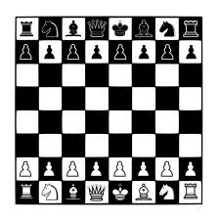 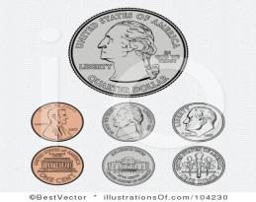 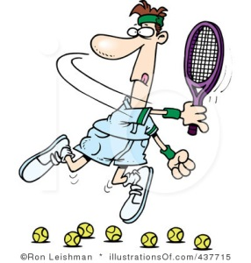

John ________________________________________________________ ____________________________________________________________

____________________________________________________________

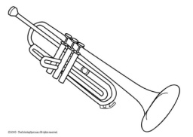  

Ted and Ben __________________________________________________

________________________________________________________________________________________________________________________

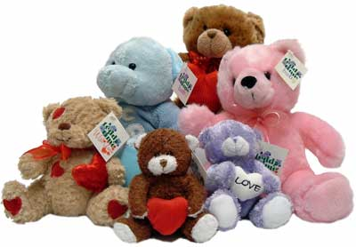  

**F. VPRAŠANJA POVEŽI Z USTREZNIM ODGOVOROM. ___/10**

|  |  |  |  |
| --- | --- | --- | --- |
| 1 | What's your name? |  | Blue. |
| 2 | Where are you from? |  | It's half past nine. |
| 3 | What colour is your book? |  | Postcards and key rings. |
| 4 | What's your favourite food? |  | Domen. |
| 5 | What's the time? |  | Yes, I do. |
| 6 | What does Andy collect? |  | London. |
| 7 | Do you play any musical instrument? |  | Cold and foggy. |
| 8 | What's the weather like? |  | Pasta. |
| 9 | How do you go to school? |  | By bus. |
| 10 | Does Nina enjoy reading? |  | Yes, she does. |

**G. NA KRATKO OPIŠI SVOJ DAN. NAPIŠI: ___/7**

* Kaj delaš zjutraj, popoldan in zvečer,
* Kaj delaš v prostem času,

________________________________________________________________________________________________________________________________________________________________________________________________________________________________________________________________________________________________________________________________________________________________________________________________________________________________________________________________________________________________________________________________________________________________________________________________________________________