TJA, TEST1. Name and surname:____________________ Date: ___  
Class: ____ Group **A** ____/47 Mark:___  
____________________________________________________________

**1.)Listen, write and draw.** Poslušaj, napiši in nariši. /5  
_ _ _ _ _ _, _ _ _ _ _ _ _ _, _ _ _ _ _, _ _ _ _ _ _ _, _ _ _ _ _ _ _.  
 **2.) Look and read. Then answer.** Poglej in preberi. Nato odgovori. /6

a)Mary is Bob's __________________.  
b)Bob is Ana's ___________________.  
c)Joan and Martin are Tim's __________________.  
d) Tim is Bob's ___________________.  
e) Maggie is Tim's ____________________.  
f) Maggie and Tim are Peter's ________________.  
  
3.) 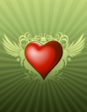 C:\Documents and Settings\Jolanda1\Local Settings\Temporary Internet Files\Content.IE5\028ZOPJQ\MC900434203[1].wmf 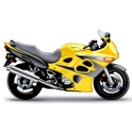 C:\Documents and Settings\Jolanda1\Local Settings\Temporary Internet Files\Content.IE5\Z6S4G4SE\MC900334790[1].wmf 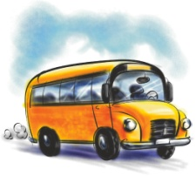 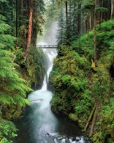  
 ________ ________ _______ __________ _________ _______  
 /6

4.) **Read and write. Beri in napiši.** /6

a) This country is in Europe. People speak English there.  
 _______________________________   
b)This country is not in Europe. It's also a continent. People speak English there.  
 _______________________________  
c) This country is in the heart of Europe. It has got about two milion people.  
 ______________________________  
 **5.) Read, circle, colour and write.** Preberi, obkroži, pobarvaj in napiši. /6 *His head is a big yellow square and his ears are two small pink circles. His hair is a yellow rectangle. His hat is a big purple triangle. His eyes are two small green stars and his mouth is a big red heart. His nose is a small brown circle.  
What is this? _________________________________*

**6.) Read and write the job.** Preberi in napiši poklic. /6  
  
a) He works at a hospital. He helps sick people. a_________________  
b) He makes people laugh. He's funny. __________________  
c) He works in a restaurant. He cooks delicious food. __________________  
d) He drives a taxi. He works days and nights. __________________  
e) He works at night. He makes bread for us. __________________  
f) He brings letters and postcards to our homes. ___________________  
*a baker, a clown, a cook, a doctor, a policeman, a postman, a taxi driver, a teacher, a vet, a bus driver,*

**7.) Read and write down anwers.** Preberi in napiši odgovore. /10  
  
The huge tower with a clock on top is called Big Ben. It's in London by the river Thames. London is the capital city of the United Kingdom.  
Sydney is the biggest city in Australia. Three milion people live here. There you can see the famous opera house in Sydney.  
Eiffel Tower is in Paris, which is the capital city of France. If you go to Paris, you can't miss it because it is very tall. From the top, you can see the whole city.  
Parthenon is a temple in Athens. It's very old. Can you count how many columns there are? Athens is the capital city of Greece.  
Slovenia is a lovely country in the south-east of Europe. It is the green heart of Europe. It looks like the shape of a chicken. We speak Slovene here. Ljubljana is the capitalč city of Slovenia. Two milion people live in my Country.  
*a) What is a huge tower with a clock on top? __________________  
b) What is the capital city of Great Britain? __________________  
c) What is the second name of Great Britain? _________________  
d) Where you can see the famous opera house? _____________  
e) Where is Eiffel Tower? ____________________  
f) What is Parthenon? _______________________  
g) Is Parthenon a very young temple? _______________________  
h) What is the capital city of Greece? ___________________  
i) What is Slovenia? ____________________________________  
j) How does Slovenia look like?* ___________________________  
 **8.) Read and complete the dialoge.** Preberi in dopolni dialog. /2  
Waiter: What would you like to eat? You: _____________________________  
Waiter: And to drink? You: _______________________________________