EIGHT PLANETS IN OUR SOLAR SYSTEM
The song: The Solar System song
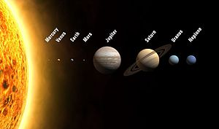
The SUN – It's a burning ball of fire.
Je goreča ognjena žoga.
Life on Earth depends on it.
Življenje na Zemlji je odvisno od njega.
1 MERCURY – It's the closest planet to the Sun.
Je Soncu najbližji planet.
2 VENUS – It's the hottest. It has no water.
Je najbolj vroč. Nima vode.
3 EARTH – It's the blue-green. It's the place where we all live.
Je modro-zelen. Je prostor, kjer mi vsi živimo.
There's a land and lots of sea. It has one moon.
4 MARS – It's a rocky red planet. It has the highest mountains.
Je skalnat rdeč planet. Ima najvišje gore.
5 JUPITER – It's the biggest planet. It's a gas giant.
Je največji planet. Je plinast velikan. Europa is its famous moon.
6 SATURN – Its rings are made of ice. Titan is its biggest moon.
Njegovi prstani so narejeni iz ledu. Titan je njena največja luna.
7 URANUS – It's the coldest planet. Its rings are made of dust.
Je najbolj mrzel planet. Njegovi prstani so narejeni iz prahu.
8 NEPTUNE – It's the farthest planet from the Sun.
Je najbolj oddaljen planet od Sonca.

