HAPPY MOTHER'S DAY 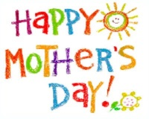
MOTHER'S DAY,
MOTHER'S DAY,
HAPPY MOTHER'S DAY,
HERE'S A GIFT
I'LL GIVE TO YOU,
ON THIS MOTHER'S DAY.
I'LL CLEAN MY ROOM,
I'LL MAKE MY BED,
I'LL PUT MY TOYS AWAY.
I'LL BE GOOD,
JUST FOR YOU,
ON THIS MOTHER'S DAY.
HAPPY MOTHER'S DAY!!!

