NAME: __________________________ DATE: ___________________________________

Write sentences by using like and don´t like

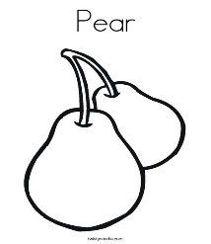

I like pears

I don’t like pears

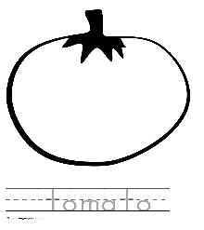

I don’t like

