Great Britain Quiz
- Choose the map of the UK.
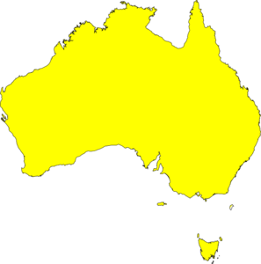
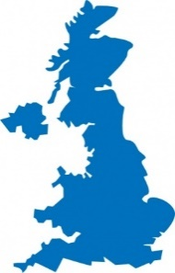
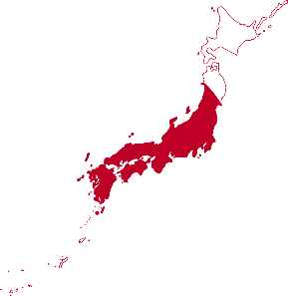
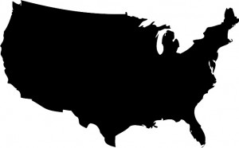
A B C D

- What is the correct name of the UK?

- The United States of America
- The United Kingdom of Scotland and Wales
- England
- The United Kingdom of Great Britain and Northern Ireland

- What are the main parts of Great Britain?

- England, Wales, California, Washington D. C.
- Italy, Germany, Ireland, France
- England, Wales, Scotland, Northern Ireland
- England, Scotland

- What is the flag of the UK?
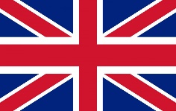
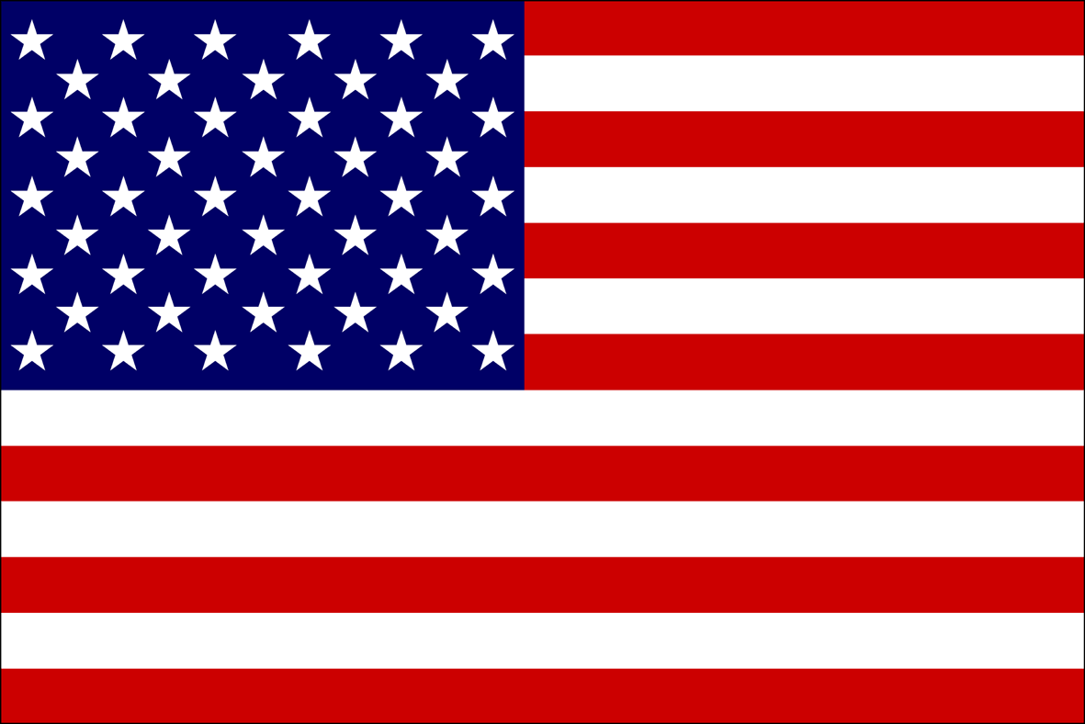
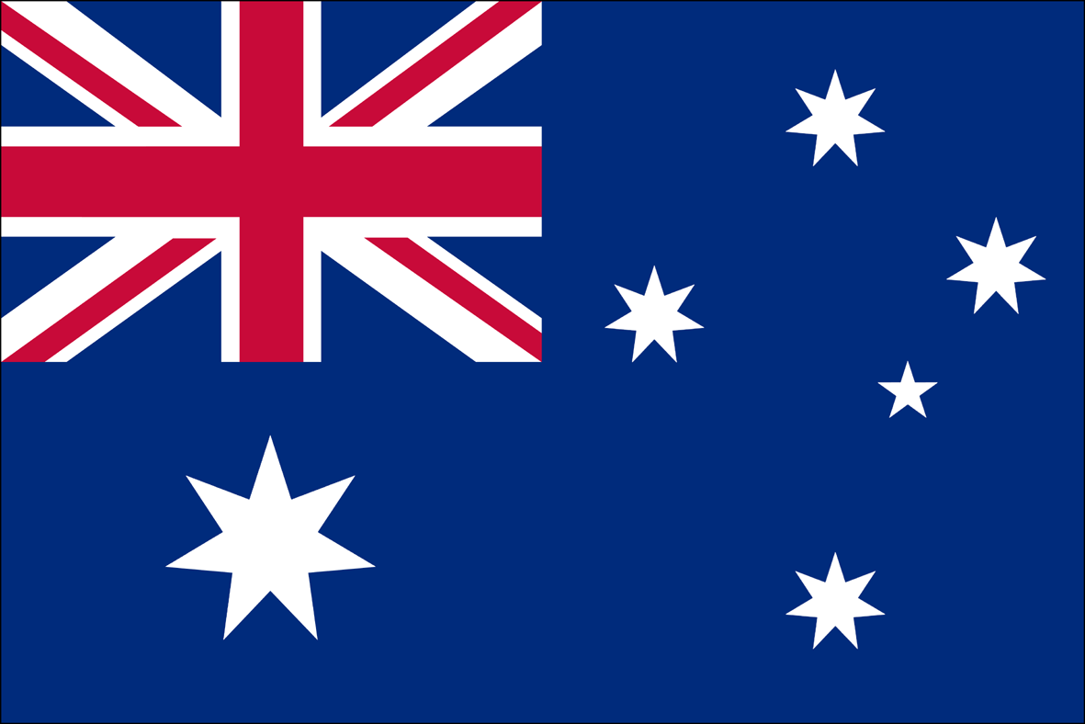
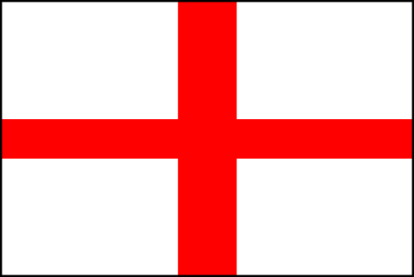
A B C D

- Choose British place of interesting.
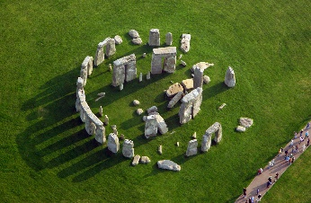
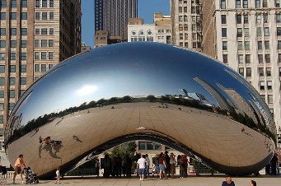
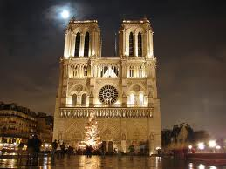
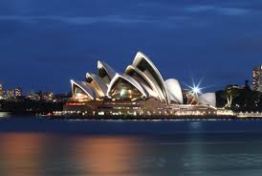
A B С D

- Choose the correct statement. Country – Capital

A England – London B England - London C England - London
Wales – Oxford Wales – New York France - Paris
Scotland – Glasgow Scotland - Edinburgh Scotland – Los Angeles
Northern Ireland - Belfast Northern Ireland - Moscow Northern Ireland - Belfast
D England – London
Wales – Cardiff
Scotland – Edinburgh What is your score? ____/ 6
Northern Ireland - Belfast

