What month is it? | What season is it? | How is the weather? | What do you wear? | What can you do?
1 – J __________ | It is ________.  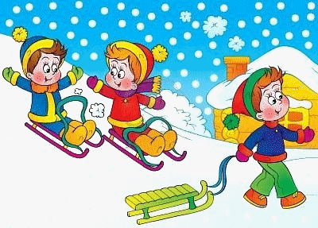 | It is ________ and ________.  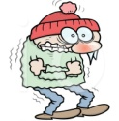 | I wear ________________  and ____________________.  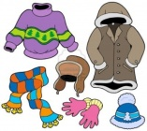 | I can _________________  and ____________________.  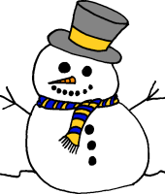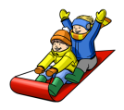
2 – F__________
3 – M__________ | It is ________.  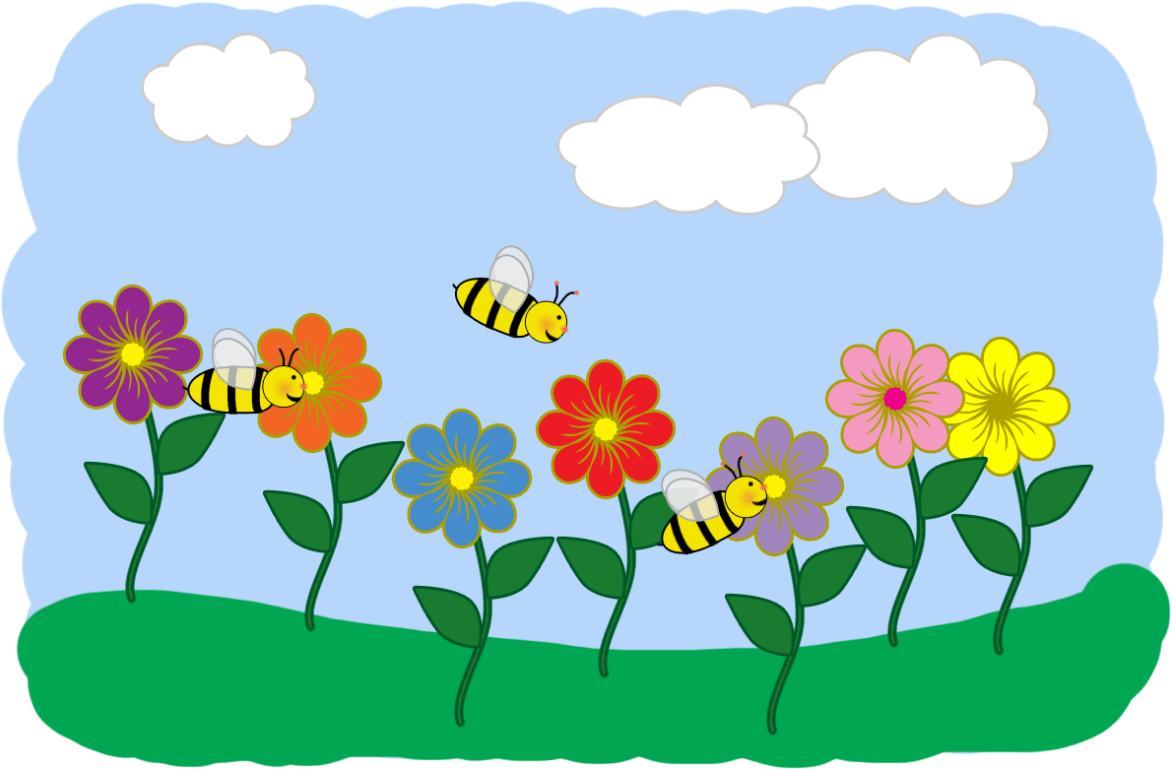 | It is ________ and ________.  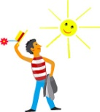 | I wear ________________  and ____________________.  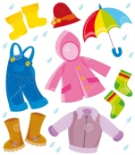 | I can _________________  and ____________________.  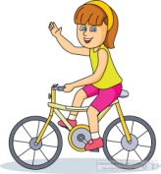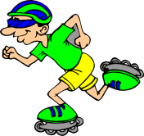
4 – A__________
5 – M__________
6 – J__________ | It is ________.  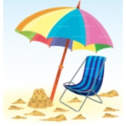 | It is ________ and ________.  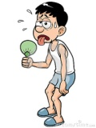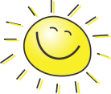 | I wear ________________  and ____________________.  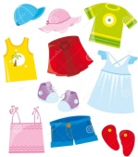 | I can _________________  and ____________________.  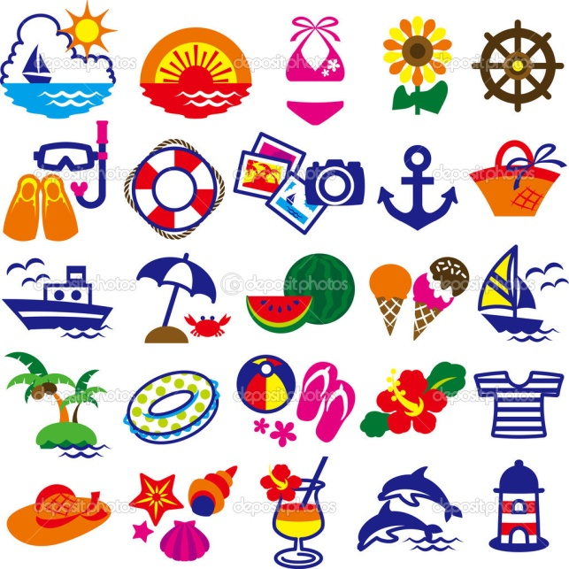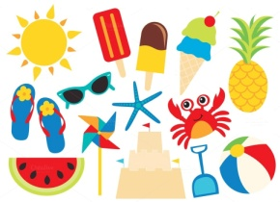
7 – J__________
8 – A__________
9 – S__________ | It is ________.  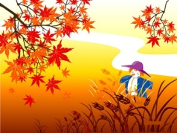 | It is ________ and ________.  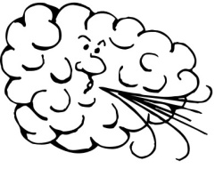 | I wear ________________  and ____________________. | I can _________________  and ____________________.  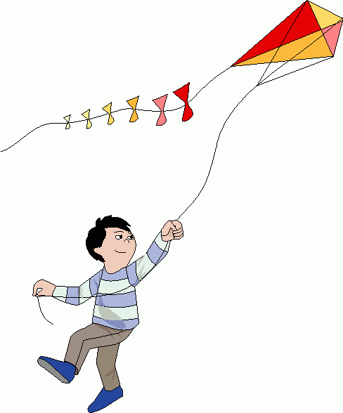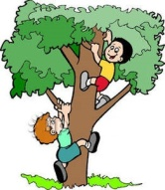
10 – O__________
11 – N__________
12 – D__________ | It is _______________. | It is ________ and ________. | I wear _______ and _______. | I can ________ and _______.
April, August, December, February, January, July,  June, March, May,  November, October, September | summer, winter  spring, autumn | hot, cold, cool, warm  rainy, sunny, windy, snowy | a hat, an umbrella, sunglasses  a shirt, a jacket, a coat, a raincoat  shorts, pants, a dress, a skirt  shoes, boots, flip flops, ice skates | fly a kite, go swimming,  ride a bike, build a snowman  go roller skating, climb a tree,  ride a sled, eat ice cream

