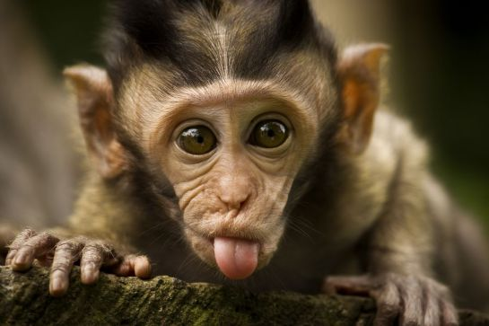
MONKEYS
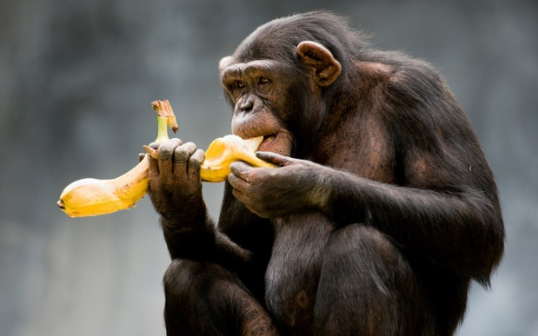
Monkeys are interesting animals. They have got hair on their body and they have got a tail. They have a face similar to human face.
They are generally vegetarian so they like fruits and vegatables.They like bananas very much. But they can eat insects,too.
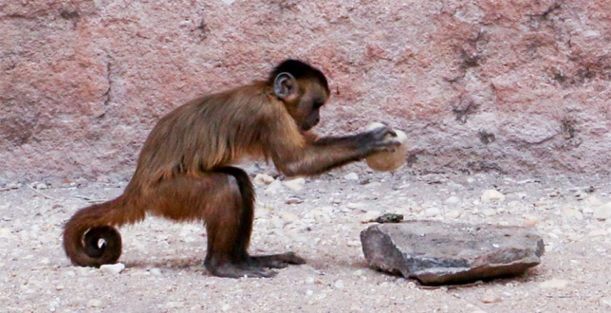

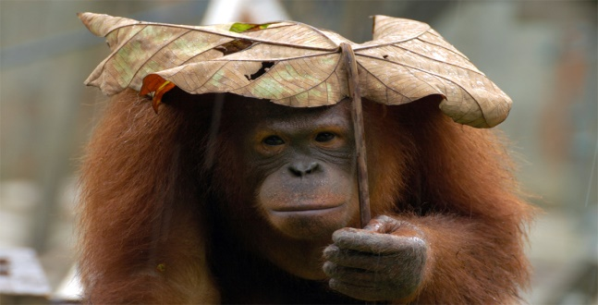
They are intelligent animals. They can use stones and they can peel fruits. Scientists teach them human language and they can understand it but they can’t speak it.
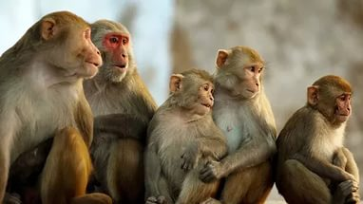
They are social animals. They have got tribes. They live in the rainforest and they sleep on the trees. They work together and they get their food. Sometimes, they work together and they steal their food from humans! They are intelligent, funny and amazing animals.

A) What are the meanings of the darker words in the text?
WORD | MEANING | WORD | MEANING
Interesting |  | Tail
Similar to |  | Generally
Insects |  | İntelligent
Stone |  | To peel
Social |  | Tribe
Rainforest |  | Together
To steal |  | Amazing

B) Answer the questions below.
Have mokeys got hair on their body?
1
_______________________________________________________
2
Can monkeys eat meat?
_______________________________________________________
3
Can monkeys peel fruits?
_______________________________________________________
4
Can a monkey speak human languages?
_______________________________________________________
5
Where do they live in?
_______________________________________________________
6
Where do they sleep?
_______________________________________________________
Can they steal food?
7
_______________________________________________________

