I LIKE THE FLOWERS
I LIKE THE FLOWERS 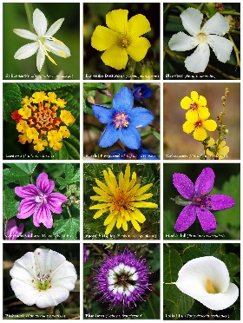,
I LIKE THE DAFFODILS 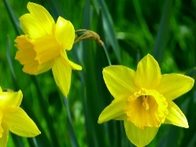,
I LIKE THE MOUNTAINS 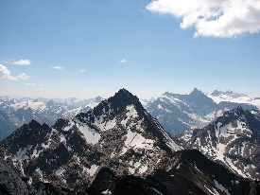,
I LIKE THE ROLLING HILLS 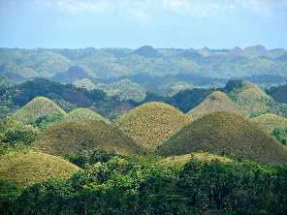,
I LIKE THE FIRESIDE 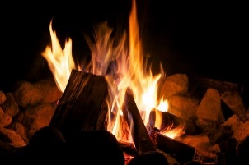,
WHEN THE LIGHTS ARE LOW.
BOOM DE AHH-DA,
BOOM DE AHH-DA,
BOOM DE AHH-DA,
BOOM DE AHH-DA.

