3.__class, ENGLISH Revision 1 / preverjanje 1. KEY April'20
Teacher: Jolanda Regouc Student's NAME:____________________

1. Match two parts of the sentences. / Poveži oba dela povedi. /8
1 My Teacher f a) is a pupil. 1 My teacher is Benjamin.
2 Tom and Steve c b) am at work. 2 Tom and Steve are boys.
3 Susan and I e c) are boys. 3 Susan and I are friends.
4 I b d) is at home. 4 I am at work.
5 My cat g e) are friends. 5 My cat is brown.
6 Mary a f) is Benjamin. 6 Mary is a pupil.
7 You h g) is brown. 7 You are pilots.
8 He d h) are pilots. 8 He is at home.
___________________________________________________________
2. Complete the following DIALOG. / Dopolni pogovor med Ano in Suzano. /7
Missing words are: Bye, you, are, fine, this, name, your.
Anna: Hello!
Susan: Hi!
Anna: What's your name?
Susan: My name is Sussan.
Anna: And who's this?
Susan: It is Joe.
Anna: How are you, Joe?
Joe: Fine, thank you, and you?
Anna: I'm fine, too.
I must go home now.
Susan: See you! Goodbye!
Anna: Bye!

3. Write numbers. /Napiši števila. /5
Numbers are: eleven, twelve, twenty, thirty-three, fourty-eight, fifty.
33 thirty-three, 11 eleven , 20 twenty
12 twelve, 50 fifty, 48 fourty-eight
4. Complete with words am, is, are./ Dopolni z besedami sem, je, so. /8
Examples: Jenny is happy. They are young.
a) Peter and I are teachers.
b) Mr Kent is in Šenčur.
c) Bob is my little dog.
d) Helen and George are at school.
e) They are not healthy.
f) My parents are in Italy today.
g) Sam is a doctor.
h) Lucy is a nurse.
i) I am at home every day.

5. What is her or his job? / Kaj je njen ali njegov poklic? Na črte pod sličice napiši poklic. /5
Jobs are: a farmer, a doctor, a stewardess, firefighters, a hairdresser.
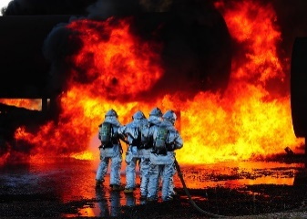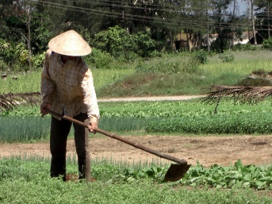
Firefighters, a stewardess, a hairdresser, a doctor, a farmer

6. Write the name of the planet. / Napiši ime planeta našega sončnega sistema. /4
Planets are: Mercury, Venus, Earth, Mars, Jupiter, Saturn, Uranus, Neptune.
- It's the hottest planet in our solar system VENUS
- It's a rocky red planet in the Milky Way. MARS
- It's the place where we live. EARTH
- It's the biggest planet. It's a gas giant. JUPITER
___________________________________________________________

