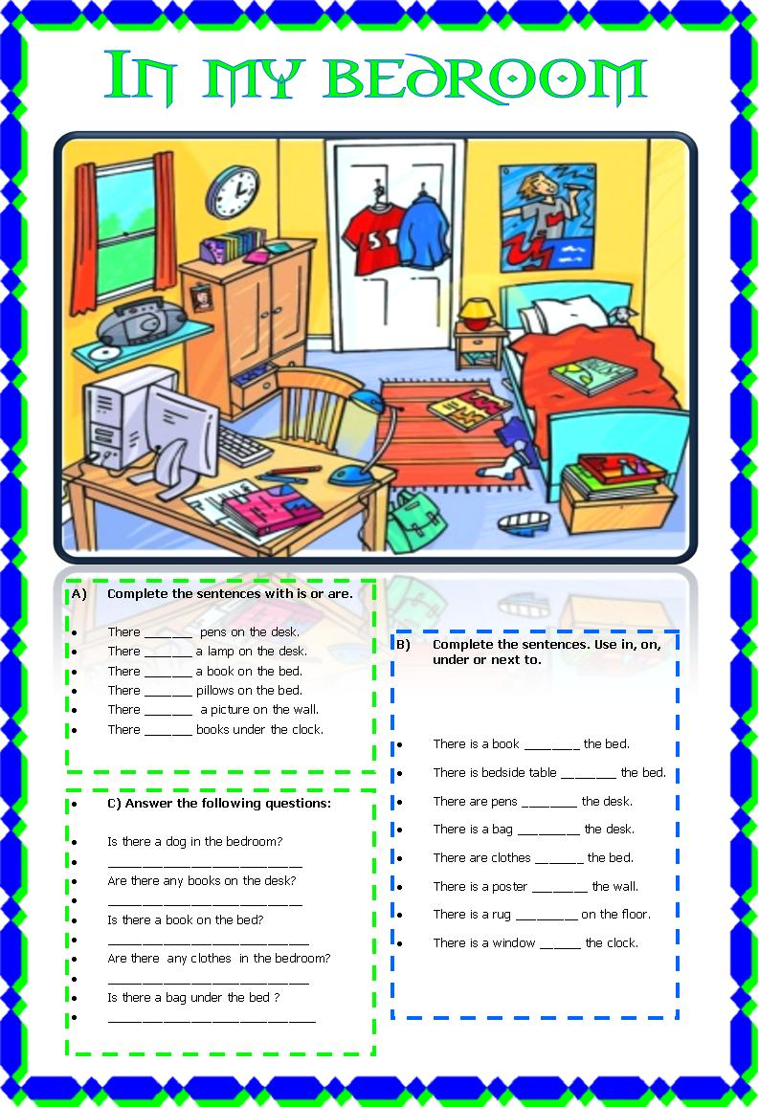
D) Look at the picture again and write sentences./Napiši povedi.
Look at the picture one more time and write sentences. / Še enkrat poglej sliko sobe in napiši povedi. V povedih uporabi predloge v, na, pod, ob in beside v zelenem okviru.
Bed books bedside table lamp chest of drawers chair rug clock poster bag pens clothes toys

Example: There are some clothes in the bedroom but there isn´t a plant next to the bed.
- ______________________________________________________________________
- ______________________________________________________________________
- ______________________________________________________________________
- ______________________________________________________________________
- ______________________________________________________________________
- ______________________________________________________________________
- ______________________________________________________________________
- ______________________________________________________________________

E) Now try to describe your own bedroom./ Opiši svojo sobo.

_____________________________________________________________________________
_____________________________________________________________________________
_____________________________________________________________________________
_____________________________________________________________________________
_____________________________________________________________________________
_____________________________________________________________________________
_____________________________________________________________________________
_____________________________________________________________________________
_____________________________________________________________________________

4.__, English, teacher Jolanda R. Revision 1. / Preverjanje 1. Student’s NAME:

