TJA, 5.class, Revision 2 Week:35.
Teacher: Jolanda Regouc Name and surname: _________________________

1. Read the text about DOLPHINS. Preberi besedilo o delfinih. /9
Dolphins are marine mammals. Bottlenose dolphins are the most common and well known type of dolphin. They can be up to 10 feet long.
Female dolphins are called cows, males are called bulls and young dolphins are called calves. When the calf is born, the mother must quickly take it to the surface so it can take its first breath. The calf will stay with its mother until it is between 3 and 8 years old.
Dolphins live in pods of up to 12 individuals. Dolphins are carnivores (meat eaters). Dolphins eat herring, cod, squid, plankton and fish. Most dolphins have streamlined bodies which are designed for agility and fast swimming. All dolphins belong to coastel dolphins or to off shore dolphins.
Coastel dolphins are typically smaller in size and prefer to stay near the coastline in shallow waters. Off shore dolphins prefer to live further out at sea away from the coastline.
Dolphins communicate using a series of clicking and whistling sounds. These sounds and body language signals are used to warn other dolphins of danger and communicate a number of other important things.
Dolphins are capable of using echolocation to find food, navigate the ocean and avoid predators. Even though dolphins have 100 teeth, they don’t use them for eating. They simple swallow fish.
A dolphin may be able to dive up to 1000 feet. Dolphins can swim at a speed of up to 25 miles per hour for a long time.
The average lifespan of a dolphin is 17 years. However, some of them that have been observed in the wild lived about 50 years.

Write TRUE or FALSE. Napiši pravilno ali narobe.
1 Dolphins are mammals. _________
2 The largest dolphins are bottlenose dolphins. _________
3 Dolphins live separately. _________
4 They are carnivores. _________
5 Dolphins use echolocation. _________
6 They have no teeth. _________
7 They can swim up to 25m/h _________
8 Dolphins can communicate. _________
9 They live 60 years. _________
.
2. Complete the sentences with words: was, were /8
Dopolni povedi.
1 There _________ one shark.
2 There _________ two turtles.
3 There _________ two octopuses and there ________ a dolphin.
4 There _________ two crabs and four seahorses.
5 There _________ fifteen seahorses and there _______ an octopus.
6 There _________twenty dolphins.
7 There _________ a turtle and there _________ eels.
8 There _________ twelve sharks and a hundred seahorses.

3. Write answers about your town. /5
Napiši odgovore o tvojem mestu Šenčur.
Yes, there is. No, there isn't. It's behind, in, on, under, next to,
in front of, opposite, between.
Example: Is there a school in your town? Yes, there is.
It's opposite the Sport Centre.

1 Is there a station in your town? _________________________
___________________________________________________
2 Is there a hospital in your town?_________________________

3 Is there a big park in your town?_________________________

___________________________________________________
4 What do you like doing in your town?_______________________

4. Read and write the number. Preberi in napiši številko. /6

1 They're small. They've got long tails. 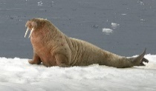 ___
They can swim. They aren't dangerous.
2 They're big. They've got tails and legs. 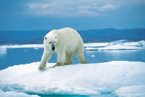 ___
They've got teeth. They're friendly.
3 They've got four legs. They're white. 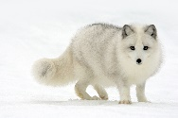 ___
They're small. They can't swim.
4 They're grey. They're not dangerous. 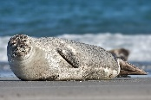 ___
They're friendly. Have they got legs? No, they haven't.
5 They've got four legs. They've got shells. 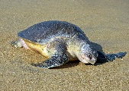 ___
Have they got long bodies? No, they haven't.
6 They've got four legs. They're white. 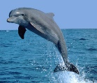 ____ 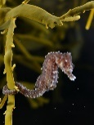 ____
They're big. They're dangerous.

5. Write answers. Napiši odgovore v celih povedih. /7
Example: What time do you have breakfast? (7.15)
I have breakfast at quarter past seven.
1 What time do you get up? (6.05) __________________________________

2 What time do you get dressed?(6.15) ______________________________

3 When do you have a shower? (6.30)________________________________

4 When do you go to school? (7.50)__________________________________

5 When do you go home? (13.20) ___________________________________

6 When do you read a book? (17.45)________________________________

____________________________________________________________
6. Write the word under the picture. /12
Imenuj slke. Je kakšna beseda odveč?
taking photos a plant a wardrobe doing exercises a lamp lacrosse a bin
an alien talking to friends playing skittles have lunch a bridge a bookcase

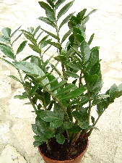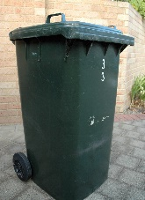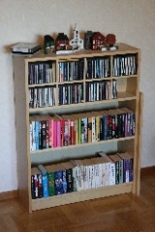
a mirror





