5.____class, English REVISION 1. / Preverjanje 1. April '20
Teacher: Jolanda Regouc Student's NAME _________________________

- 1.Where do you live? Read the text and answer the questions. / Preberi besedilo in napiši odgovore.
Sam lives in a new small flat in a town. His address is 34 Down Street. His flat’s got two rooms. It hasn’t got a balcony. But there’s a big basement where he enjoys watching films and listening to music. Now Sam is taking pictures of his flat and smiling.
Nina lives at 65 Lake Road. She lives in a big house in a beautiful village. She likes riding her bike there. At the moment, she is carrying her bike upstairs. Nina’s house has got three floors. There are ten rooms, eight balconies and a nice garden. But there isn’t a basement.
Tim lives in a flat in a very big city. His address is 100 Gold Street. It’s on the 5th floor. There are six rooms. His favourite room is a dining room. Tim loves having dinner there. He loves cooking, too. Right now he’s making chocolate cake for his sister. She is reading a book on the balcony.
Lilly lives in the country. Her house at 96 Milk Road is small, but very nice. It’s got two floors. There is a living room, a kitchen and a dining room downstairs. Upstairs, there are two bedrooms and a big bathroom. Lilly’s house has got a basement, two balconies and a small garden. She likes sleeping there.
Questions: Short answers: /12
- Who lives at 100 Gold Street? ___________________________________________
- Where does Nina live? _________________________________________________
- What’s Lilly’s address?_________________________________________________
- Is there a balcony in Sam’s flat?__________________________________________
- How many floors has Nina’s house got?_____________________________________
- What’s Tim’s sister doing? ______________________________________________
- Where does Sam like listening to music?____________________________________
- Who lives in the country?_______________________________________________
- Has Nina’s house got a basement?_________________________________________
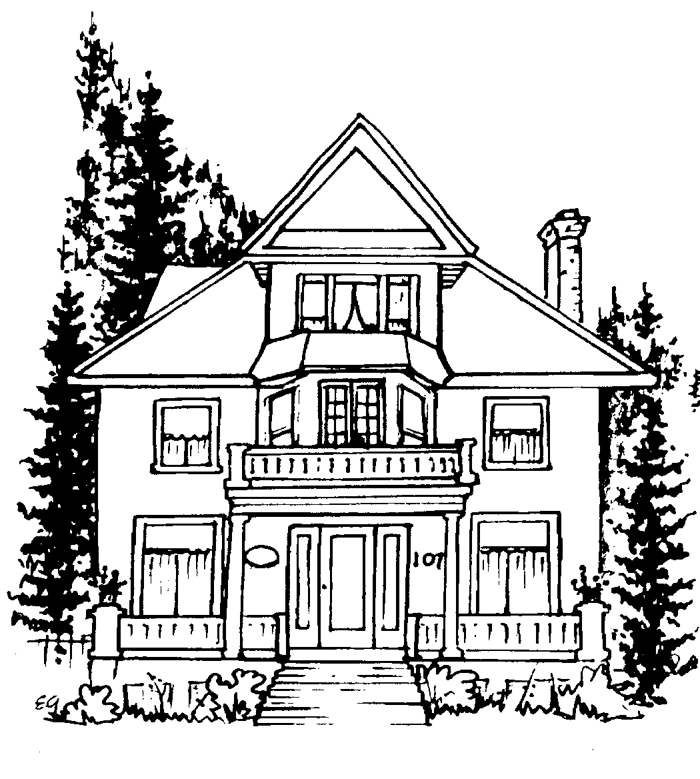
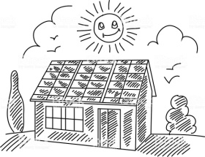
- How many rooms are there in Tim’s flat?____________________________________

2. Add the missing word was or were./ Dodaj manjkajočo besedo was ali were. /8
I was, You were, She/He/It was, They were, We were, Tom and Richard were, People were, A child was
Angelina Jolie and Brat Pitt

Angelina: My teddy bear! Where __________ you last night?
Brad: I __________ with my manager. Then I went to sing karaoke.
Angelina: __________ you alone at karaoke?
Brad: No, I __________ (not). It __________ an old friend with me and some coworkers.
Angelina: __________ there any women too?
Brad: My sugar pie, don’t worry! There __________ (not) any women.
Angelina: Better for you. Don’t make me beat you like last time.
Brad: I swear to God! There __________ (not) anyone you could be jealous at.
Angelina: OK, I believe you. Now you can go put our six children to sleep and make me
a dinner.
Brad: Thank you baby. Running… love you!

3.Choose the correct option. /Izberi pravilen odgovor. /8
1. It________ cold today. a) am b) is c) are
2. I_________ at home now. a) am b) is c) are
3. They_______ Korean. a) am b) is c) are
4. There________ a pen on the desk. a) am b) is c) are
5. My name________ Nikita. a) am b) is c) are
6. We_________ from Ukraine. a) am b) is c) are
7. I________ OK, thanks. a) am b) is c) are
8. She_______ an English teacher. a) am b) is c) are

4, Answer. /Odgovori v celi povedi. /4
* Are the dolphins carnivores? ______________________________________________
* What do dolphins eat?___________________________________________________
* What animals are mammals? ______________________________________________

