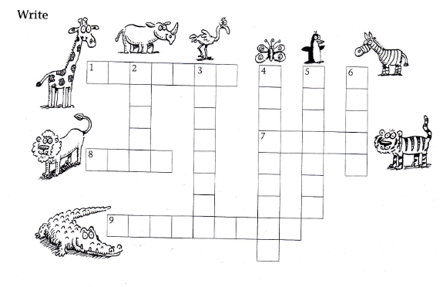
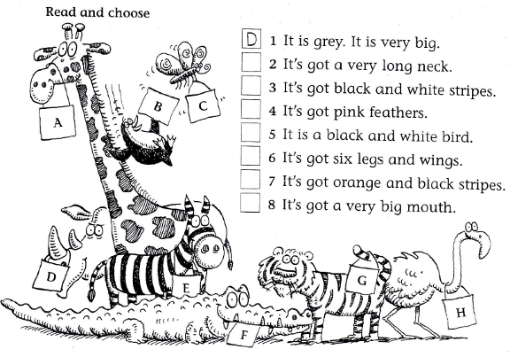
WILD ANIMALS CROSSWORD
A GIRRAFE. A LION, A RHINO (RHINOCEROS), A ZEBRA, A TIGER, A CROCODILE, AN OSTRICH, A PENGUIN, A BUTTERFLY

