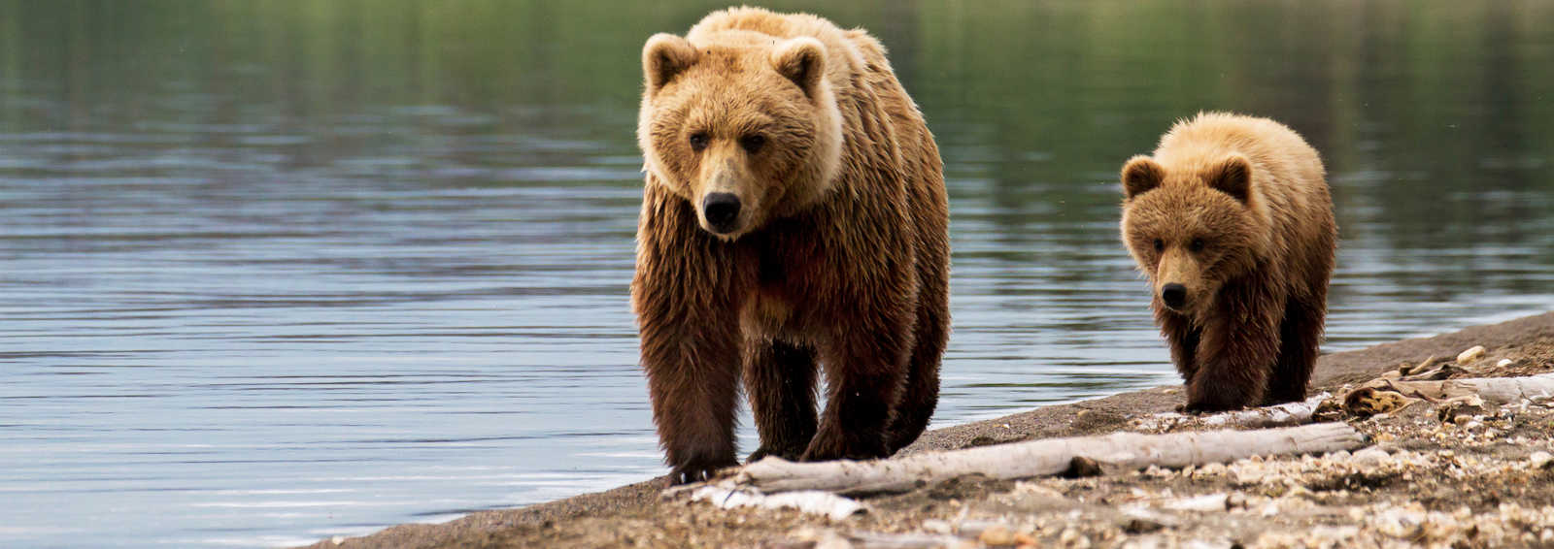

The Brown Bear (Ursus Arctos), the speech

A brown bear is the second largest land carnivore in the world next to the polar bear, and can be found all across northern Eurasia (Europe + Asia) and North America.
In North America, they are often called “Grizzly bears”, and in some European countries the brown bear is the national animal.
The brown bear is widely spread out throughout Russia, Central Asia, China, the United States and Canada and Europe.
In Slovenia there are
Brown bears vary greatly in size, depending on their habitat and their access to food. The largest is the Kodiak bear which lives in Alaska.
Brown bears usually avoid contact with humans. In Russia only one in a thousand meetings with brown bears results in an attack, whereas in North America, attacks from brown bears result in two deaths per year.
They are mostly solitary animals. It means that they prefer to live alone or in small numbers and will not usually gather in large groups unless there is a major food source, such as an open river where salmon are in great supply.

