FAT CAT MAT 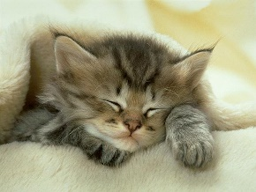
I GOT A CAT, WHO WEARS A WHITE HAT,
I GOT A CAT, WHO LIKES IT LIKE THAT,
I GOT A CAT, WHO LIES ON A MAT,
HE'S SUCH A FAT CAT.
HE LIKES IT LIKE THAT.
I GOT A CAT, WHO LOOKS LIKE A RAT.
I GOT A CAT, WHO CAN SWING A BAT.
I GOT A CAT, WHO PURRS LIKE A BRAT,
WHEN THAT CAT DOESN'T GET HIS SNACK.
THAT'S MY CAT, MAT.
HE'S A REALLY FAT CAT.
THAT'S MY CAT, MAT.
HE'S A REALLY FAT CAT.
THAT'S MY FAT CAT.
THAT'S MY FAT CAT, MAT.
MAT FAT CAT
FAT CAT MAT
THAT'S MY FAT CAT.
THAT'S MY FAT CAT, MAT.
MAT FAT CAT
FAT CAT MAT

