MIX, MIX, MIX! 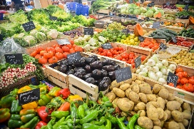
BOB BUG HAS A BIG PAN AND A LOT OF TINS.
BOB CUTS UP A BUN.
BOB TIPS IN A POT OF JAM.
BOB CUTS UP A LEMON, A MELON, A FIG.
MIX, MIX, MIX! BOB RUBS HIS TUM.
BOB TIPS IN A LOT OF NUTS. MIX, MIX, MIX!
DAD BUG SAYS, »YUK!«
MUM BUG SAYS,« YUK!«
BUT BOB BUG SAYS, »YUM YUM!

