English, 3.___ class, teacher Jolanda Regouc REVISION 2.
NAME: _________________ /30
1. Read and write the words under the pictures. Pod slike napiši besede. /7
A churc, a library, a school, a bus station, a shop, a hospital,
a playground, a hotel, a post office, a bank, a butcher, a bakery
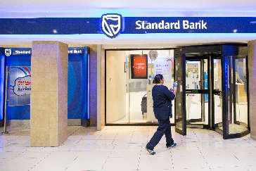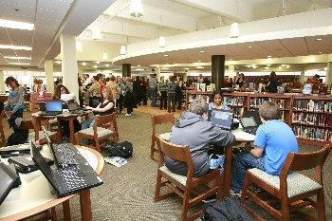
_______________ ____________________ ______________
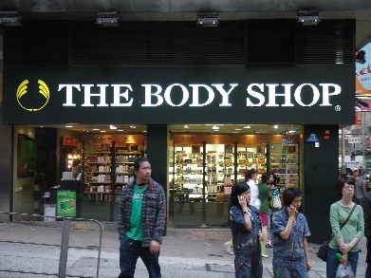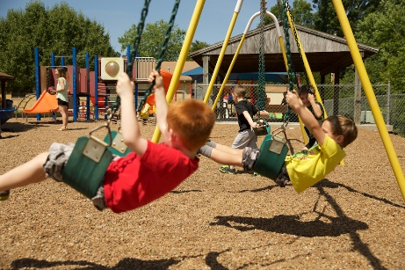
________________ _________________ _______________
2. Read and add a missing word. Preberi in dodaj besedo, ki manjka. Dve besedi sta odveč.
/6
1 The Sun is the burning ___________ of fire.
Jupiter, live, ball, Mercury, red, hottest, Saturn
2 Earth is the place where we all ___________.
3 Mars is a rocky ___________ planet.
4 Venus is the ___________ planet.
5 _____________ has got rings.

3. Name the continents and oceans.
Imenuj kontinente in oceane. Imena napiši na črto. Antarctica se ne vidi. /12
The Pacific Ocean, Europe, Africa, The Northern Ocean, North America, Asia, Atlantic, Antarctica, South America, The Indian Ocean, Australia, The Arctic Ocean
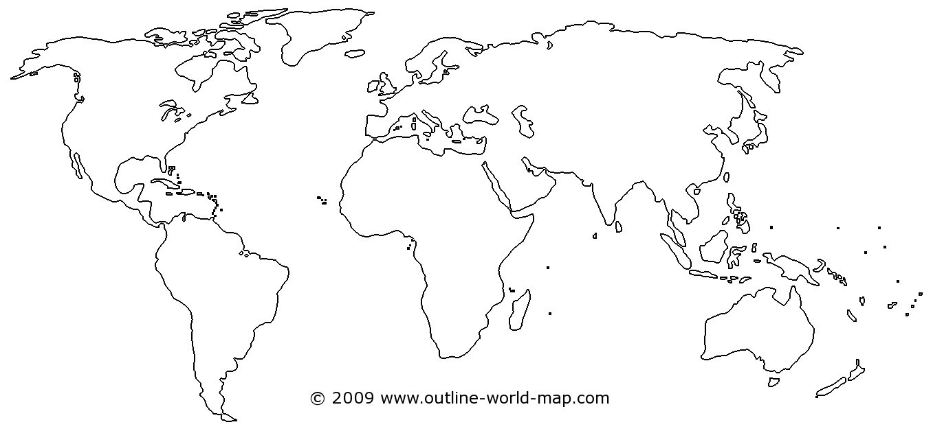

4. Read and circle the right answer. Preberi in obkroži pravilen odgovor. /2
* What is the capital city of Slovenia?
a) Šenčur b) Kranj c) London d) Ljubljana
5. What time is it? Koliko je ura? /3
1 It's 7.15. a) It's quarter to seven. b) It's quarter past seven.
2 It's half past eight. a) 8.30 b) 9.30 c) 8.00
3 It's one o'clock. a) 1.05 b) 12.00 c) 1.00

