3.ad, Lesson: 58., 59. Week: 36. Učiteljica: Jolanda Regouc
1. Questions about time/čas are:
- What time is it, please? 6.00: It's six o'clock in the morning.
- What's the time, please? 18.00: It's six o'clock in the evening.
2. 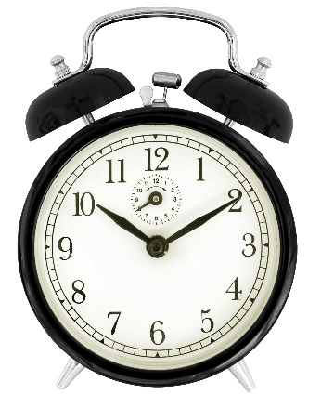
What's this? This is a clock.
It has got two hands: a long hand and a short hand.
Ima dva kazalca: dolgi kazalec in kratki kazalec.
It has got numbers from one to twelve.
Ima številke od 1 do 12.
What time is it, please? It's ten past ten.
Koliko je ura, prosim? Ura je deset čez deset,
3. What time is it? Write the answers.
a) 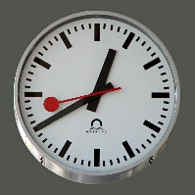 It's twenty to one. Je 20 minut do enih.
b) 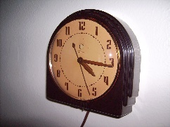 It's quarter past four. Je četrt čez 4.
c) 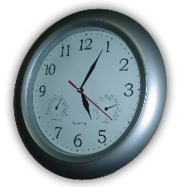 It's five past five. Je pet čez pet.
4. Repeat. Ponavljaj.
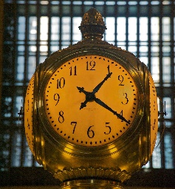 It's ________________________________
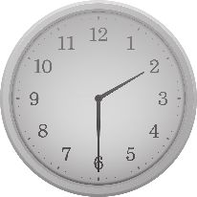 It's ___________________________________
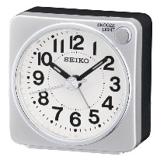 It's ___________________________________
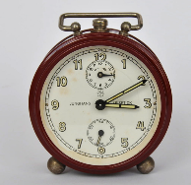 It's ____________________________________
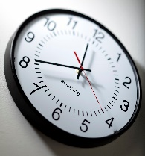 It's ____________________________________
5. Draw a clock. It's twenty past eight in the morning.
Nariši uro. Je 20 minut čez 8.

