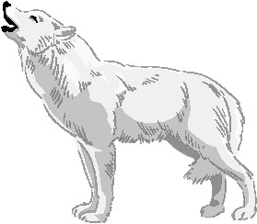
WOLVES, the speech

Wolves are legendary because of their howl, which they use to communicate.
A wolf howls to attract the attention of his pack, while communal howls send territorial messages from one pack to another. Much like barking domestic dogs, wolves may simply begin howling because a nearby wolf has already begun.

Wolves are the largest members of the dog family. Gray wolves are the most common and they are found all over the Northern Hemisphere. Wolves almost never attack humans. They are one of the world's most fearsome animals. They do attack domestic animals. People (hunters and farmers) shot lots of wolves.

Wolves live and hunt in packs of around six to ten animals. They are known to roam large distances, perhaps 20 kilometers in a single day. These social animals hunt their preferred prey - large animals such as deer, elk, and moos. A single animal can consume 9 kilograms of meat. Wolves also eat smaller mammals, birds, fish, lizards, snakes and fruit.
Wolf packs live in a strict hierarchy. The dominant male is at the top and his mate not far behind. Usually this male and female are the only animals of the pack to breed. All of a pack's adults help to care for young pups by bringing them food and watching them, while others hunt.

