

**Present Simple**

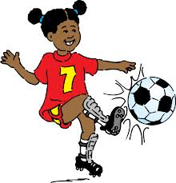

She plays football.

She does not play football.

Does she play football?



They sing carols.

____________________________

_____________________________________ ?



Mary paints a picture.

____________________________

_____________________________________ ?



Sasha dances.

_____________________________

_____________________________________ ?

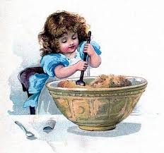

Zlata cooks every week.

____________________________

_____________________________________ ?

The girls read books.

_____________________________

_____________________________________ ?

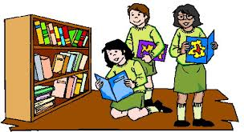

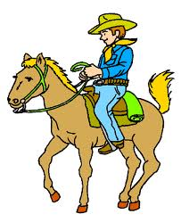

Egor rides a horse.

_____________________________

_____________________________________ ?

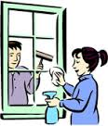

They clean windows every month.

_____________________________

_____________________________________ ?





He is running.

_____________________________

_____________________________________ ?

He is running.

_____________________________

_____________________________________ ?

He is running.

_____________________________

_____________________________________ ?